Section 1
General Information
A | School / Department: | School of Informatics
B | Brief description of the activity:  Start to finish, step by step | Experiments with human participants using TMS, stroboscopic light and psychometric scales.
C | Location(s) covered by this risk assessment:  Include building and room number if applicable | SCCS labs, Chichester 2
D | Equipment and materials used: | Computer, Monitor, Keyboard, Laptop, custom stroboscope: twelve 4500k J2 6V  white LEDs organised in a three-by-four grid with dimensions 128 x 176mm (width x height).  Transcranial Magnetic Stimulation (TMS) equipment from CE certified manufacturer MagStim rapid² TMS, x4 figure of 8 coils, TMS coil clamp.
E | Name(s) / Group(s) involved in the activity:  Consider Staff, Students, Visitors, Contractors and members of the public | David Schwartzman (Experimenter/Post Doc/Lab Manager), Anil Seth (Director, Sussex Centre for Consciousness Science, SCCS), Trevor Hewitt (PhD student), Danny Nacker (PhD student), Róisín Sharma (Undergraduate student) (ONLY under direct supervision and completion of Centre SOPs for safe use of EEG and Strobe). Other members of the SCCS (PhD students, postdocs, faculty) may use the lab after training and completion of Centre SOPs.
F | Name of person completing this risk assessment:  Students and PhD students should only complete risk assessments for their projects. Sign off for all student projects should be by the student’s supervisor. | Róisín Sharma | Signature |  | Date: | 26/03/2026
G | Risk assessment approved by:  The individual approving the risk assessment should be familiar with the work being undertaken. This should in most cases be the assessor’s supervisor, line manager or the principle investigator. |  | Signature |  | Date:
H | Send a copy to School/Department Safety Coordinator

Section 2 Hazards & Controls
See the accompanying guidance document on the safety section website for further information on how to complete this form.
 |  | Risk with current control measures |  |  |  | Risk after additional control measures
Potential  hazards | Who might be harmed and how? | What current controls are in place to avoid harm? | Likelihood 1-5 | Severity 1-5 | Risk (L S) | What further control measures are required to reduce risk? | Likelihood 1-5 | Severity 1-5 | Risk (L S) | Who  will do this? | When must this be done? | Completed on:
Exposure to stroboscopic light | Individuals with light sensitivity to bright or stroboscopic light | As part of the Dreamachine project, specialists in sensitivities to stroboscopic light, including photosensitive epilepsy, were consulted. In collaboration with an extensive health and safety team and the event safety company Event Safety Shop, a comprehensive safety screening form was developed to mitigate risks associated with stroboscopic exposure. Participants who do not pass this screening will be excluded. The effectiveness of this procedure is demonstrated by the nearly 40,000 individuals who safely participated in Dreamachine.  During the experiment, participants will be continuously monitored via camera for any signs of adverse reactions to the stroboscopic stimulation. The experimenter will have access to an emergency stop button to immediately terminate the stimulation if necessary. Participants will also be instructed that they can stop the experience at any time by covering their eyes, at which point the experiment will cease.  Photobiological safety will be maintained by ensuring that stroboscopic stimulation does not exceed a maximum luminance of 7000 lux, in accordance with the European directive guidelines (Directive 2006/25/EC). | 1 | 4 | 4 (L) | None
TMS use in experimental context | People with sensitivities to brain stimulation by TMS | All participants will be safety screened prior to inclusion in the TMS experiment in accordance with established guidelines (Rossi et al., 2021). Specifically, screening procedures will follow: Safety, ethical considerations, and application guidelines for the use of transcranial magnetic stimulation in clinical practice and research.  In order to conduct a TMS experiment within the SCCS lab, the experimenter is required to provide proof of current first aid responder training.  A Standard Operating Procedure (SOP) has been developed outlining safety mitigation strategies and detailing the protocol to be followed in the unlikely event of an adverse reaction. | 1 | 4 | 4 (L) | None
Electric Shock from portable appliances | Lab users | All laboratory equipment should be CE certified. At least operatives must visually inspect the equipment before its use, when appropriate equipment would have been PAT Tested. | 1 | 3 | 3 (L) | None
Slip and Trip Hazards | Lab users | All cables will be hidden behind furniture. Where this is not possible, any cables required to transverse walkways or steps will be taped down with hazard tape. | 1 | 2 | 2 (L) | None
Fire | Burns, loss of consciousness and major losses. All staff members, visitors | Students and staff must adhere to established emergency procedures. In the event of a fire, individuals must raise the alarm, alert others, and evacuate the building immediately. Personal belongings must not be retrieved, and no attempts should be made to extinguish the fire using fire extinguishers. | 2 | 5 | 10 (M) | Briefing on means of escape and assembly point locations will be provided to students and their supervisors during induction. Participants will also receive instruction on fire exit locations. Participants will not be left unsupervised and will remain accompanied at all times by a member of staff trained in fire emergency procedures. | 2 | 2 | 4 (L) | Lab users | During induction
Continue additional pages if required

Section 3 Risk Matrix
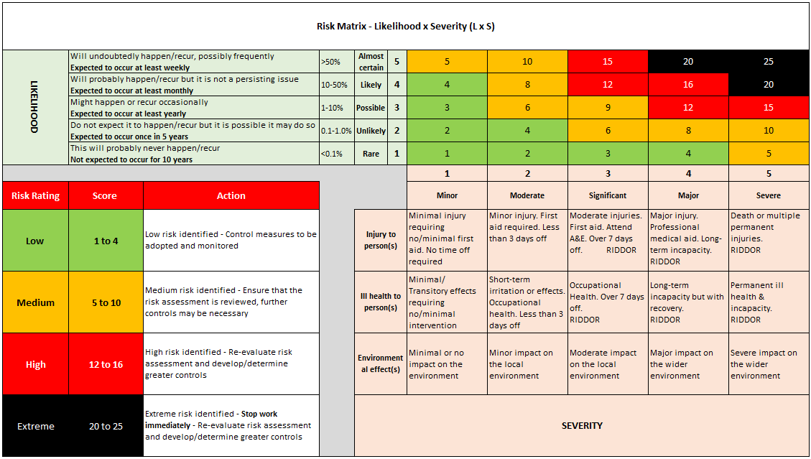
Section 4 Communication of Risk Assessment to Users

This assessment can either be communicated to groups or Individuals as part of a School or Divisional process or signed off by individual users.

School or Divisional Process
The contents of this risk assessment will be communicated to builder users in the University training programmes.

Sign off by users
All individuals carrying out activities covered under this risk assessment should sign below after reading it.
By signing this document you confirm that; you have read and understood this risk assessment and that it is an accurate representation of work practice
Name | Signature | Date | Name | Signature | Date
Róisín Sharma |  | 26/03/2026

Section 5 Record of Risk Assessment reviews
Risk assessments should be reviewed every three years or earlier if there is a significant change in the process or after an incident/near miss
Date of review: |  | Reviewed by: |  | Comments / date of next review:
Date of review: |  | Reviewed by: |  | Comments / date of next review:
Date of review: |  | Reviewed by: |  | Comments / date of next review:

